Truncated Dodecahedron

Definition
# Source: AI Source: Provided by: [Data Path: Persons Table -> ID Column: 1, Name_En Column: Motasem Essam] -> From: [ChatGPT] on [7/25/2026]
A Truncated Dodecahedron is a three-dimensional polyhedron formed by cutting off the twenty vertices of an original dodecahedron using planes.
The truncation process creates twenty new triangular faces while modifying the original twelve pentagonal faces into decagonal faces.
A uniformly truncated dodecahedron is an Archimedean solid.

Geometric Structure
# Source: AI Source: Provided by: [Data Path: Persons Table -> ID Column: 1, Name_En Column: Motasem Essam] -> From: [ChatGPT] on [7/25/2026]
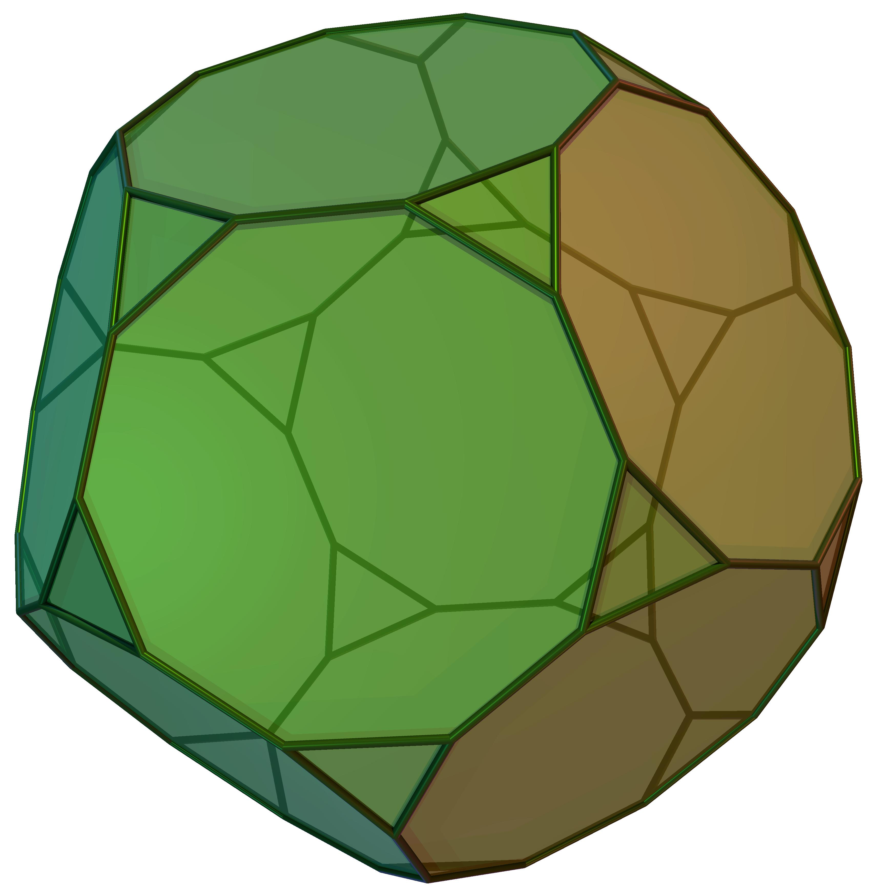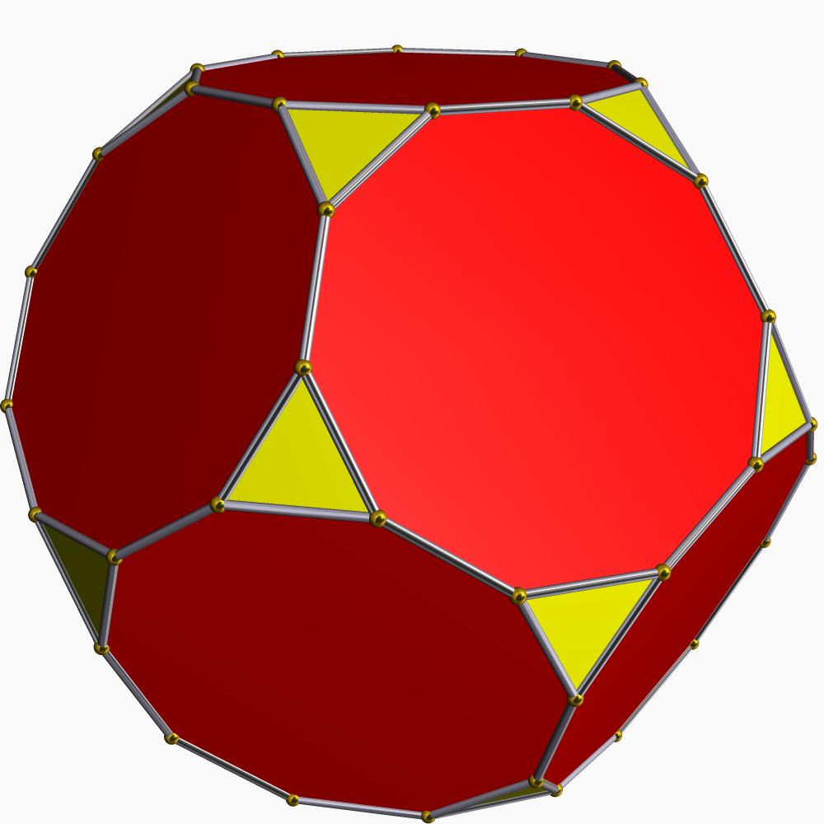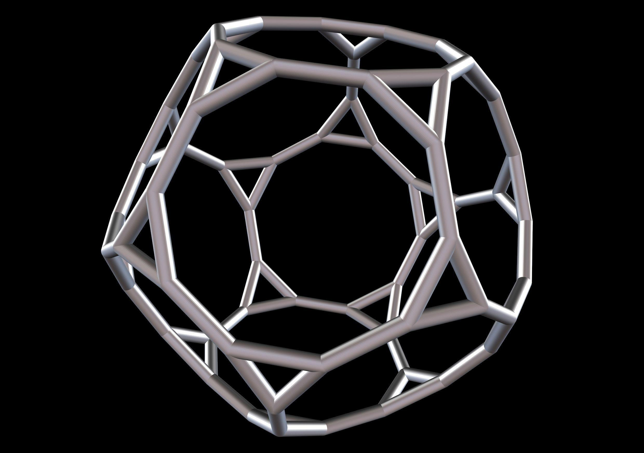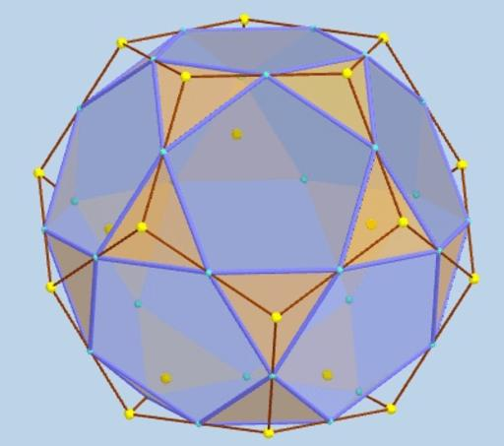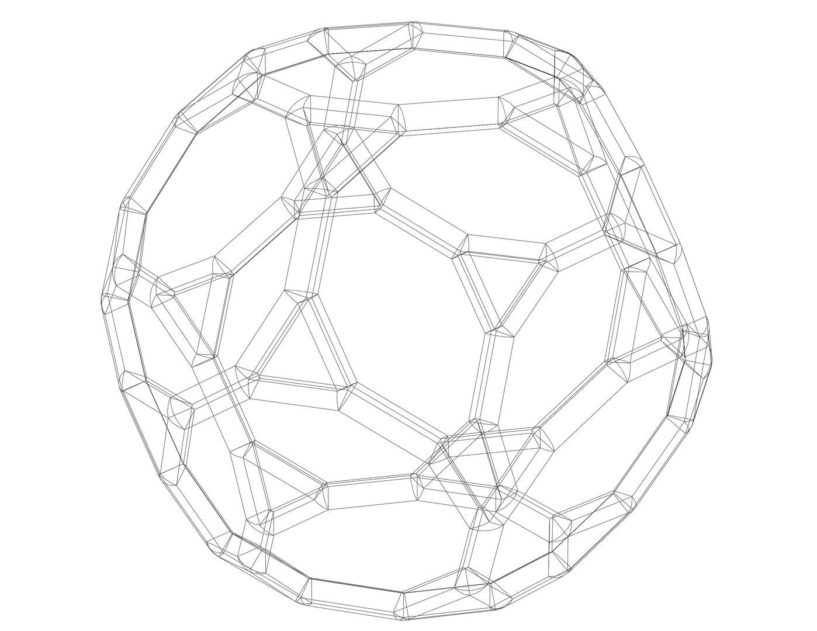
A truncated dodecahedron consists of:
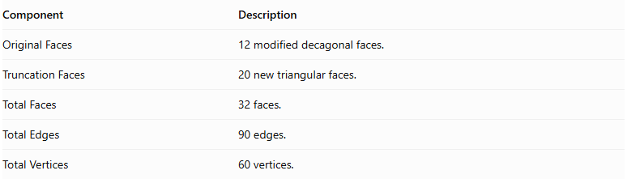
Component | Description
Original Faces | 12 modified decagonal faces.
Truncation Faces | 20 new triangular faces.
Total Faces | 32 faces.
Total Edges | 90 edges.
Total Vertices | 60 vertices.

Face Composition
# Source: AI Source: Provided by: [Data Path: Persons Table -> ID Column: 1, Name_En Column: Motasem Essam] -> From: [ChatGPT] on [7/25/2026]
The truncated dodecahedron contains two types of polygonal faces:
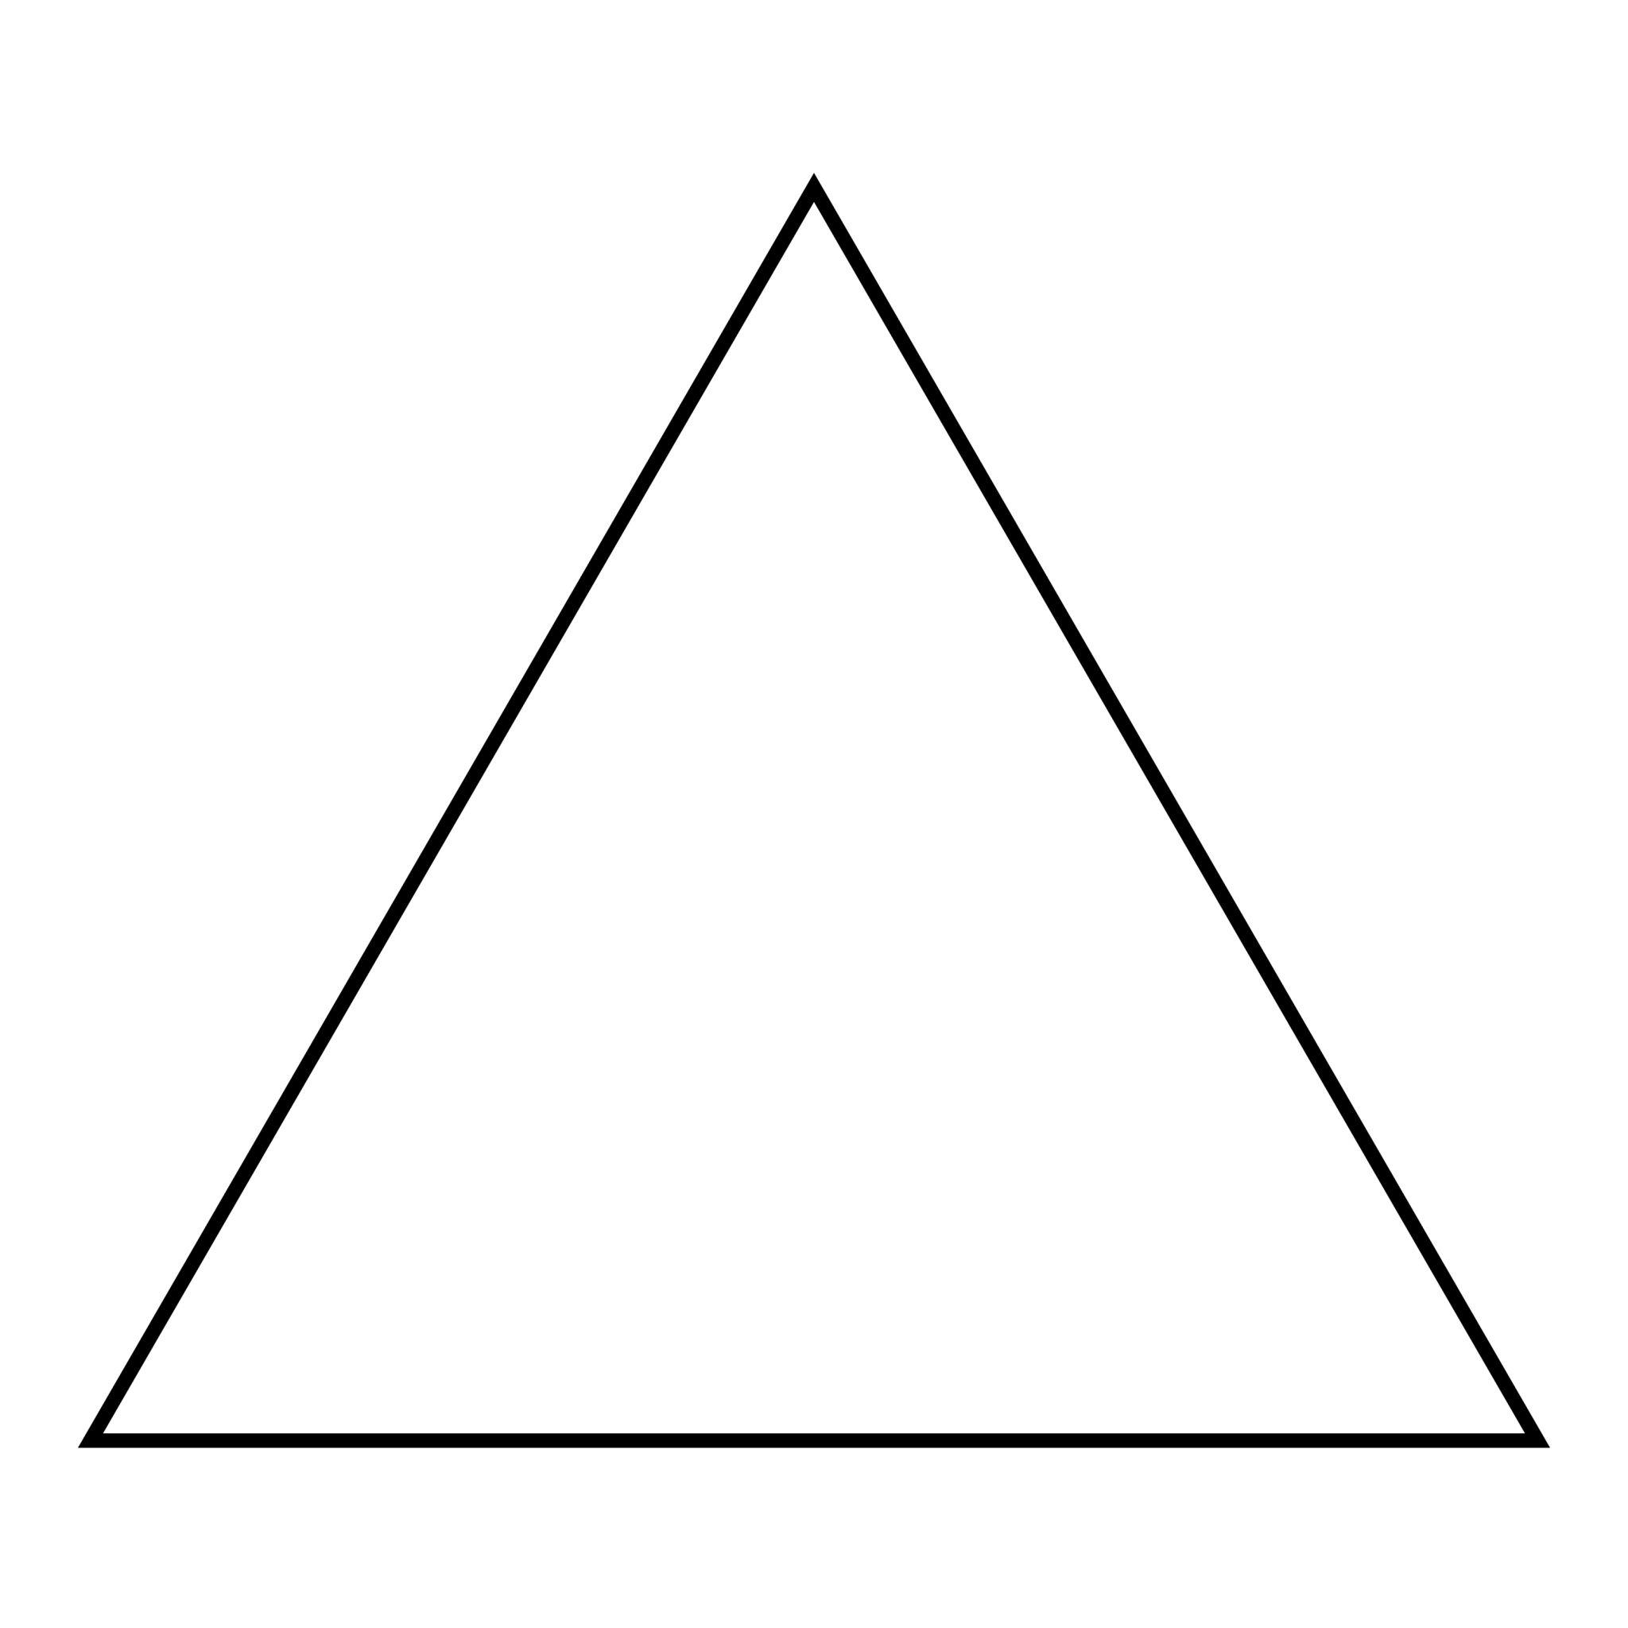

Triangular Faces
# Source: AI Source: Provided by: [Data Path: Persons Table -> ID Column: 1, Name_En Column: Motasem Essam] -> From: [ChatGPT] on [7/25/2026]
- Number: 20
- Shape: Equilateral triangles.
- Origin: Created by truncating the twenty original vertices.
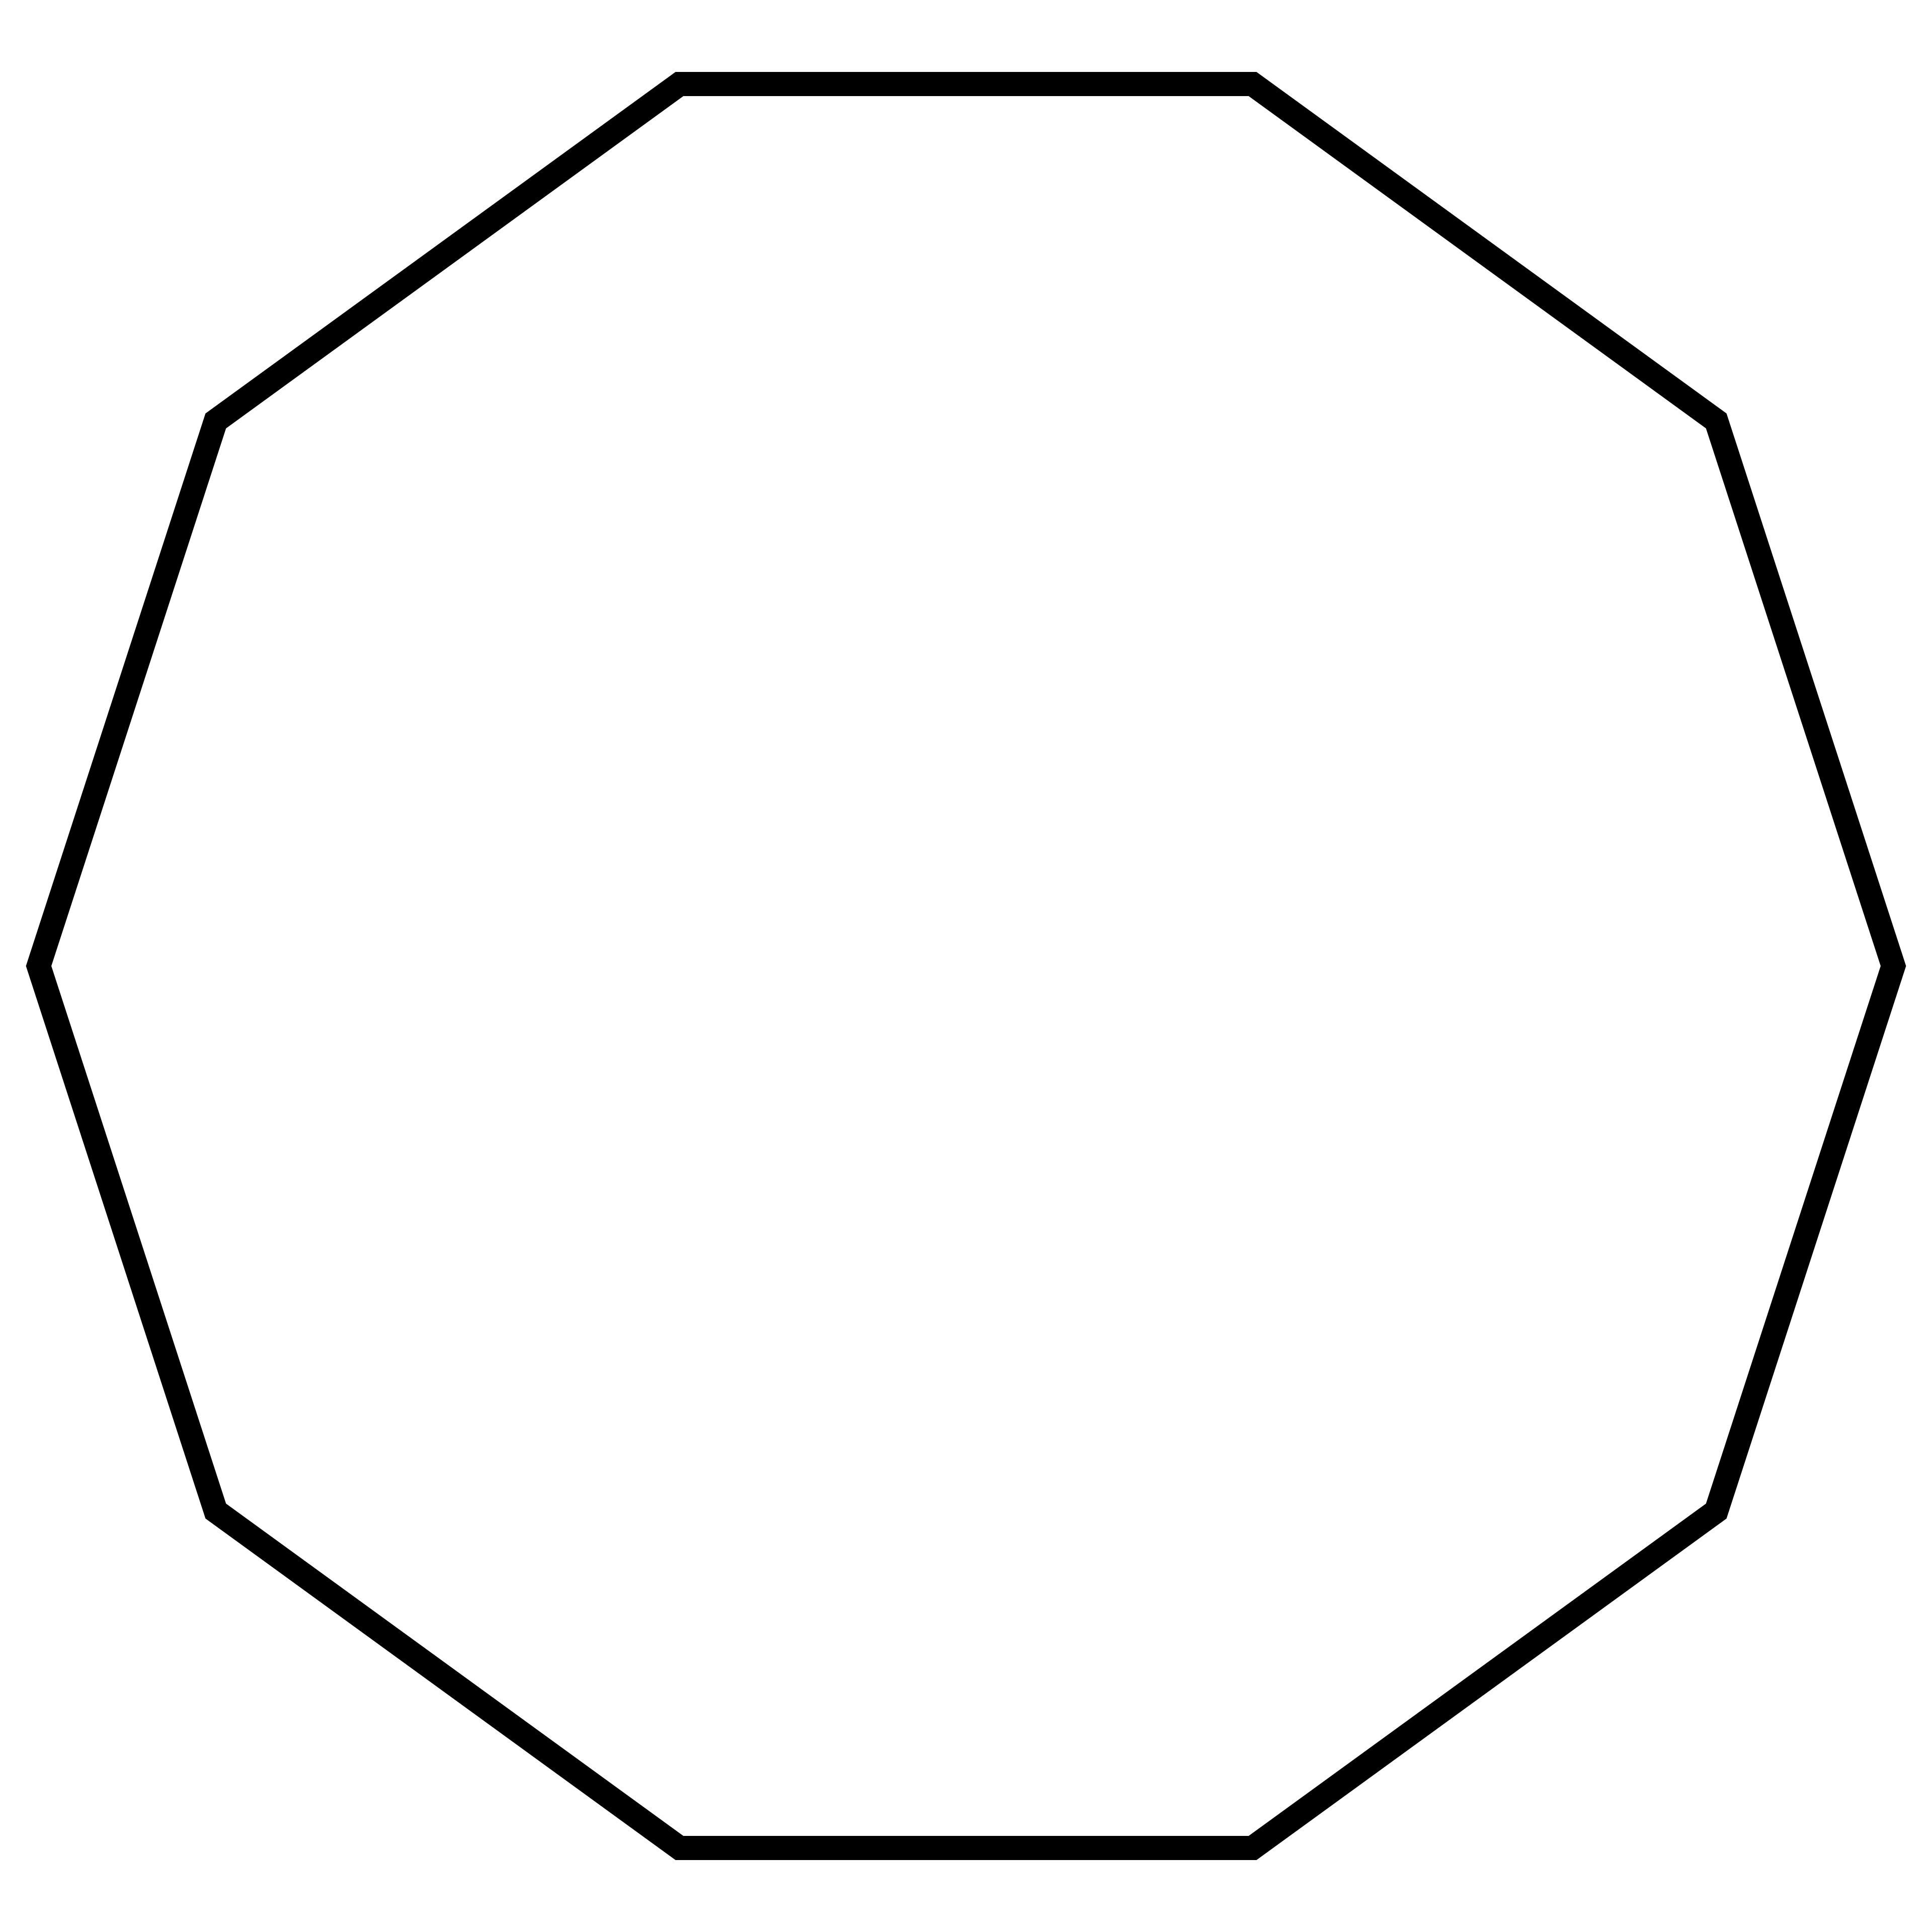

Decagonal Faces
# Source: AI Source: Provided by: [Data Path: Persons Table -> ID Column: 1, Name_En Column: Motasem Essam] -> From: [ChatGPT] on [7/25/2026]
- Number: 12
- Shape: Regular decagons.
- Origin: Modified from the twelve original pentagonal faces.

Mathematical Properties
# Source: AI Source: Provided by: [Data Path: Persons Table -> ID Column: 1, Name_En Column: Motasem Essam] -> From: [ChatGPT] on [7/25/2026]
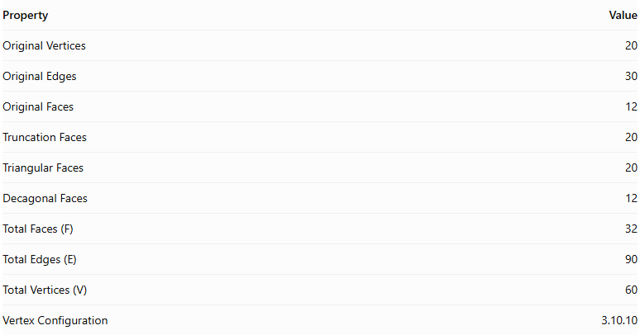
Property | Value
Original Vertices | 20
Original Edges | 30
Original Faces | 12
Truncation Faces | 20
Triangular Faces | 20
Decagonal Faces | 12
Total Faces (F) | 32
Total Edges (E) | 90
Total Vertices (V) | 60
Vertex Configuration | 3.10.10
Euler's Formula:
$$V-E+F=2$$
Substituting:
$$60-90+32=2$$
Therefore, the truncated dodecahedron satisfies Euler's formula.

Key Points
# Source: AI Source: Provided by: [Data Path: Persons Table -> ID Column: 1, Name_En Column: Motasem Essam] -> From: [ChatGPT] on [7/25/2026]
- It originates from a regular dodecahedron.
- All twenty original vertices are truncated.
- It has 20 equilateral triangular faces and 12 regular decagonal faces.
- It contains 90 edges and 60 vertices.
- It is an Archimedean solid when uniformly truncated.
- Its faces are regular polygons.

Conclusion
# Source: AI Source: Provided by: [Data Path: Persons Table -> ID Column: 1, Name_En Column: Motasem Essam] -> From: [ChatGPT] on [7/25/2026]
The Truncated Dodecahedron is an Archimedean solid formed by uniformly truncating the twenty vertices of a regular dodecahedron. It consists of twenty equilateral triangular faces and twelve regular decagonal faces, with a total of 32 faces, 90 edges, and 60 vertices.

